Modeling the impact of outbreak response immunization on typhoid fever using data from 19 outbreaks between 2000-2022.

Abstract

Background
Typhoid fever continues to be endemic in many low- and middle-income countries, with 48 reported outbreaks between 1989 and 2018. The emergence of antimicrobial-resistant S. Typhi has triggered epidemics in regions that were previously unaffected. Typhoid conjugate vaccines provide a means of preventing and controlling these outbreaks. However, the potential impact of outbreak response immunization for typhoid fever, particularly how factors such as coverage and timing influence outbreak dynamics, remains poorly understood.

Methods
We evaluated the potential impact of single-dose typhoid conjugate vaccine outbreak response strategies using a previously published time series dataset of outbreaks between 2000 to 2022. A static model was applied to 19 individual typhoid outbreaks, incorporating factors such as direct and indirect vaccine effectiveness, delays in the onset of vaccine-induced immunity, and cost-effectiveness analyses.

Findings
Across the 19 typhoid fever outbreaks, the median duration and size of outbreaks was 27.5 weeks and 805.5 cases, respectively. The median timing to community-based intervention was 7 weeks and the median target population size was about 280,000 people. Given a delay in outbreak response immunization of eight weeks and 80% coverage, outbreaks reporting weekly incidence demonstrated a median percent case reduction of 30.0% (95%CI: 0% - 68.5%), translating to a median of 275 (95%CI: 0 - 2,787) cases averted. The median cost per DALY averted was $82,756 (95%CI: 0 - 618,927) and the median cases averted per 1,000 doses was 0.63 (95%CI: 0.062 - 8.76). The delays in ORI timing, vaccine coverage, and outbreak characteristics such as duration and size, were important in determining the potential impact on typhoid burden.

Conclusion
Outbreak response immunization is a valuable strategy for mitigating typhoid fever outbreaks. By reducing the overall number of cases, ORI can substantially lessen the public health burden and contribute to more effective outbreak control, especially in combination with other interventions (such as water, sanitation, and hygiene) and in resource-limited settings.

Research in Context

Evidence before this study
We searched PubMed on December 19, 2024, with no language or date restrictions, using the search terms ((typhoid fever[Title/Abstract]) OR (typhoid[Title/Abstract])) AND (vaccin*[Title/Abstract]) AND (model*[Title/Abstract]) AND ((impact*[Title/Abstract]) OR (effect*[Title/Abstract]) OR (predict*[Title/Abstract])). This resulted in 161 articles for screening. Individual studies that focused on typhoid fever transmission modeling to investigate the impact of vaccination scenarios were included, which identified a total of 12 relevant studies^{1–12}. These previous studies either evaluated data from one or a small number of geographic locations, evaluated only routine immunization scenarios or did not consider the additional burden of antimicrobial resistant cases in their analyses. No study to date has utilized real outbreak data from almost 20 outbreaks to evaluate the impact of reactive outbreak response immunization on typhoid fever.

Added value of this study
This study advances existing research by utilizing real outbreak data from 19 published typhoid outbreaks to assess the impact of reactive outbreak response immunization scenarios on typhoid case burden and their cost-effectiveness. Parameters such as direct and indirect vaccine effectiveness and delays in vaccine-derived immunogenicity, outbreak response initiation, and campaign duration are considered. Varying vaccine coverages and timing are evaluated. Cost parameters such as costs of vaccine procurement, delivery, equipment, and direct and indirect medical costs are incorporated for cost-effectiveness analyses. Outbreak response impact measures such as total and percent of cases averted, cost per DALY averted, and cases averted per 1,000 doses are computed and desCIbed.

Implications of the available evidence
Outbreak response immunization can be an important strategy in preventing and mitigating typhoid fever outbreaks. Across the studied outbreaks, given a realistic delay of eight weeks and 80% vaccine coverage, ORI could avert 30.0% (95% CI: 0% – 68.5%) of typhoid cases or 275 (95%CI: 0 - 2,787) total cases. These estimates are sensitive to delays in response timing and coverage, highlighting the importance of a global vaccine supply that is accessible and timely.

Introduction

Typhoid fever is a systemic illness caused by the Gram-negative bacterium Salmonella enterica serovar Typhi (S. Typhi), and it remains endemic in many low- and middle-income countries, particularly where clean water and adequate sanitation are lacking¹³. In 2021, an estimated 7.15 million cases of typhoid fever occurred globally (95% CI: 5.57 – 9.23 million), resulting in approximately 93,000 deaths (95% CI: 46,257 – 158,181)¹⁴. Although effective antibiotics can reduce typhoid case fatality rates to below 1%, the growing emergence of antimicrobial-resistant S. Typhi poses a serious public health threat, sparking outbreaks in regions that had not previously been affected¹⁵. Between 2000 and 2022, 43 typhoid outbreaks were reported in the literature¹⁶.

Typhoid conjugate vaccines (TCV) offer an effective method for prevention and mitigation of outbreaks, especially as a short-term tool in places that require time and investments into improving access to clean water, sanitation, and hygiene infrastructure¹⁷. Since 2018 and 2020, two single-dose TCVs have been available, Typbar TCV® (Bharat Biotech) and TYPHIBEV® (Biological E), while two more TCVs were recently prequalified by the World Health Organization (WHO) in 2024, SKYTyphoid™ (SK bioscience) and ZyVac® TCV (Zydus Lifesciences Limited)^{18–20}. The WHO recommends TCV for routine administration as a single dose to children from six months of age to adults of 45 years of age living in endemic regions, as well as for use in catch-up campaigns for those up to 15 years old¹⁹.

Since 2017, five countries have received Gavi support for routine immunization and catch-up campaigns using TCVs. However, only Zimbabwe has been granted funding specifically for outbreak response in 2019, despite the occurrence of typhoid outbreaks in other countries¹⁹. This limited response may stem from challenges in reporting, confirming, and characterizing the local epidemiology of typhoid, which hinders the accurate estimation of TCV needs. According to UNICEF (2022), while an annual supply of 6.5 million TCV doses is considered secure in the coming years, actual demand may range between 42.7 and 77.1 million doses¹⁹. Mathematical modeling offers a valuable tool for understanding typhoid transmission dynamics and evaluating the potential impact of TCVs. However, most prior modeling efforts have centered on routine or preventive vaccination in endemic settings, often limited to single or few locations. As epidemic outbreaks become increasingly concerning, partly due to the rise of antimicrobial-resistant S. Typhi, there is a pressing need to study the impact of outbreak response immunization (ORI) strategies to inform future TCV deployment and policy decisions.

This study utilizes a dataset of 43 typhoid outbreaks reported between 2000 and 2022 compiled by Koh et al. (2025), to assess the potential impact of ORI in outbreaks that range in size, duration, and geographic and temporal contexts. Our analysis incorporates key parameters including direct and indirect vaccine effectiveness, delays in vaccine-derived protection, as well as costs related to both vaccination and illness. Using these inputs, we estimate measures of vaccine impact and cost-effectiveness such as percent case reduction, cases averted per 1,000 doses, and costs per DALY averted.

Methods

A total of 43 typhoid outbreaks between 2000 and 2022 were reported in the dataset by Koh et al. (2025). Of these, twenty-four outbreaks were excluded for being in a Gavi funding-ineligible country (as of 2025)²¹ (n = 17), having a prior vaccination campaign (n = 2), being very short (n = 1), and having other nested location-specific outbreaks already in the dataset (n = 2). A final total of 19 outbreaks were included for modeling, in which 6 reported daily incidence of suspected cases, 7 reported weekly incidence, 1 reported fortnightly incidence, and 5 reported monthly incidence (Figure 1).

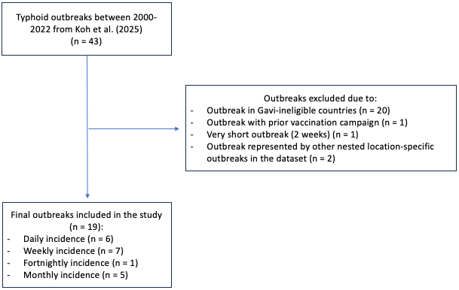
Figure 1. Overview of final typhoid outbreaks included in the study.

A static model was employed to model the impact of TCV on outbreaks. Since the focus is on epidemic outbreaks in native settings, the model focuses on the immediate impact of ORI and does not consider recurrent campaigns in the same population. The overall vaccine effectiveness, $P_{i, π}$, is estimated using the following equation²²:

$$P_{i, π}=1-\left[π\left(1-ψ_{i}\right)\left(1-η_{π}\right)+\left(1-π\right)\left(1-η_{π}\right)\right],$$

Where $P_{i, π}$ represents the proportion of cases averted for age group $i$ and vaccine coverage $π$, $η_{π}$ represents the indirect vaccine effectiveness, and $ψ_{i}$ represents the direct vaccine effectiveness.

The cumulative number of cases under a given vaccination campaign is then calculated as follows:

$$C_{i,π,τ}=\sum_{t=1}^{T}{I_{t,i}\left[1-1\left(t≥τ+δ\right)P_{i, π}\right]},$$

Where $C_{i,π,τ}$ represents the cumulative number of cases for age group $i$, vaccine coverage $π$, and time $τ$, $I_{t,i}$ represents the incidence at time $t$ for age group $i$, and $1\left(x\right)$ is an indicator function that equals 1 if $x$ is true and 0 otherwise. The term $δ$ represents the delays in campaign implementation and development of vaccine-derived immunity, and $T$ denotes the outbreak's end date.

Each outbreak was analyzed individually and the models compared counterfactual case reduction from vaccination scenarios with observed outbreaks in which no vaccination occurs. Outbreaks that reported daily incidence were aggregated to the weekly scale and the outbreak that reported fortnightly incidence was aggregated to the monthly scale. To align with previously published studies, the main text will present results for outbreaks on the weekly time unit. Additional analyses for outbreaks on the monthly time unit are also performed and presented in the supplementary material.

Figure 2 presents hypothetical counterfactual outbreak scenarios, highlighting the potential range of vaccine impact across a diverse set of outbreaks. For example, some outbreaks may conclude before an ORI can be initiated (blue), while others, despite lasting longer, may still be too brief to observe any measurable effect (orange) due to delays in the onset of vaccine-induced immunity. Impact is also influenced by outbreak size, where larger outbreaks could show greater impact (green) compared to outbreaks with smaller weekly cases (purple). However, timing remains critical because if an ORI is initiated too late, even a large outbreak may be missed entirely, while a smaller but more prolonged outbreak may still permit a detectable effect. In Figure 2, impact is defined by the percent reduction in cases from the number of cases without vaccination to the number of cases with vaccination.

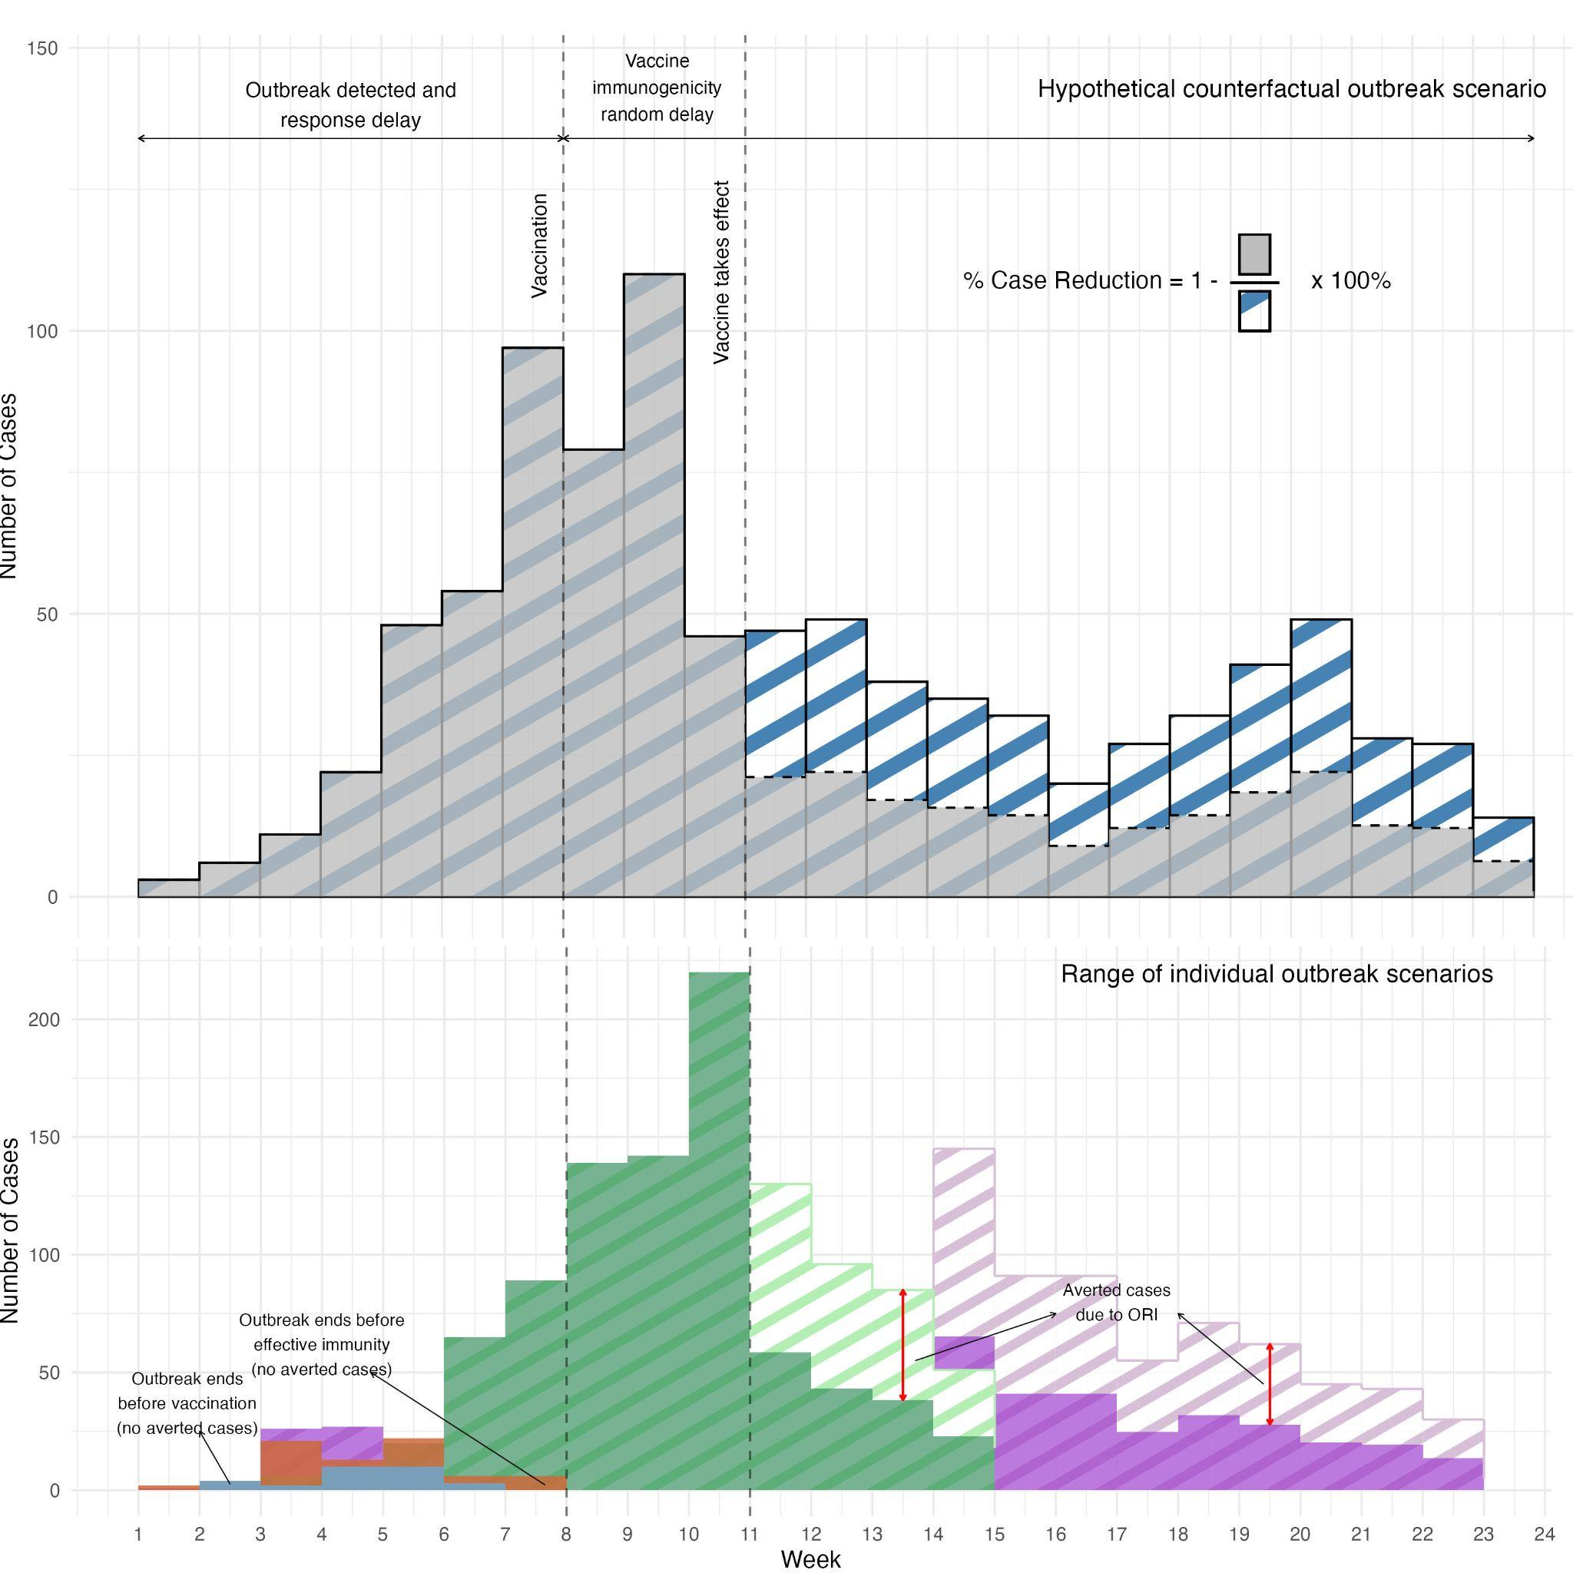
Figure 2. Hypothetical counterfactual outbreak scenarios across the diverse set of individual outbreaks. Blue: Madaya, Myanmar (2000); Orange: Amritsar, India (2019); Green: Harare, Zimbabwe (2011-2012); Purple: Harare, Zimbabwe (2016-2017)

Other campaign-, vaccine-, illness-, and cost-related parameters used in the model are found in Table 1. In previous randomized controlled trials of TCVs, seroconversion to vaccine-derived immunity was typically assessed at 28 days following the first dose^{17,23–25}. In the study with the greatest number of total participants receiving TCV (n = 283), the rate of seroconversion at day 28 was 98.6% (95% CI: 96.4 – 99.5)²⁴. Across all cited studies, the rate of seroconversion at 28 days post-vaccination ranged from 87.8% to 100%. Since this time point was selected to ensure the capture of all immunologic responses, we adopted this as the maximum time frame in our study. However, it is plausible that some individuals may have had prior exposure to S.Typhi, resulting in partial or full natural immunity. In such cases, the first dose of TCV may act as a booster, resulting in a more rapid or enhanced immune response²⁶. This is further supported by evidence showing that the second dose of TCV produces only a modest increase in antibody titers, likely because levels are already elevated following the initial dose²⁷. To account for this possibility, we defined 14 days post-vaccination as the lower bound for seroconversion.

Direct and indirect vaccine effectiveness and campaign duration were sampled (n = 200) from parametric distributions using Sobol sequence methods²⁸. Impact and cost-effectiveness of outbreak response immunization could be greater in areas that have positive AMR cases, and thus the burden of AMR was set to twice the burden of antimicrobial-sensitive cases, in line with previous studies^{2,8}. All costs were transformed using the global annual percent change in average consumer prices and reported in 2025 USD$²⁹. Outbreaks without reported target population size in the original data (n = 7) were supplemented with imputed values obtained from online sources (Supplementary Table 1), corresponding to the smallest administrative level described in the original outbreak report.

Table 1. Model parameters.
Description | Value | Source
Campaign-related
Vaccine coverage (%) | 80% (63 – 95) | ³⁰
ORI timing delay (weeks) | 8 | Assumed from data
Campaign duration (days) | 14 (3 – 21) | ³¹
Vaccine-related
Delay in vaccine-derived immunity (days) | 21 (14 – 28) | ^{17,23–25}
Direct vaccine effectiveness by one dose of TCV | 83% (77–87%) | ³²
Indirect vaccine effectiveness | 17% | ³³
Typhoid fever-related
Proportion of moderate, severe, GI bleed, and intestinal perforation infection | Moderate: 0.35 (0.26 – 0.443)  Severe: 0.4775 (0.38 – 0.574)  GI Bleed: 0.17 (0.10 – 0.257)  Intestinal Perforation: 0.0025 (0 – 0.02) | ¹⁴
Disability weight for moderate, severe, GI bleed, and intestinal perforation infection | Moderate: 0.051 (0.032 – 0.074)  Severe: 0.133 (0.088 – 0.19)  GI Bleed: 0.325 (0.209 – 0.462)  Intestinal Perforation: 0.324 (0.22 – 0.462) | ³⁴
Duration of illness (days) | Moderate: 14 (7 – 21)  Severe: 28 (14 – 49) | ³⁵
Burden of AMR cases relative to antimicrobial-sensitive cases | 2 (1 – 3) | ²
Cost-effectiveness
Vaccine cost of procurement per dose | $1.50 | ³⁶
Vaccine delivery cost per dose | $0.39 (0.01 – 0.63)** | ²
Vaccine injection and safety equipment per dose | $0.23 | ²
Cost per outpatient | $36.58 (0 – 149)** | ²
Cost per inpatient | $148.76 (20 – 457)** | ²
Life expectancy at mean age of infection | 56 years (46 – 66)*** | ³⁷
Gross Domestic Product (GDP) per capita | $4,440 (907 – 57,040)*** | ³⁸
Annual percent change average consumer price | From 2017 to 2025: 4.9 (3.2 - 8.6) | ²⁹
Age distribution | Under 2 years: 0.07 (0.06 - 0.08)  2 to 4 years: 0.10 (0.09 - 0.11)  5 to 16 years: 0.32 (0.31 - 0.35)  16+ years: 0.50 (0.45 - 0.52) | ³⁷
*paper reports -0.13, however authors choose to set this to zero since this is not mechanistically possible
**Country-specific, mean (range)
***Country- and year-specific, mean (range)

Eleven outbreaks reported the implementation of at least one community-based large-scale outbreak response intervention. Among these, water source chlorination was the most common, reported in 7 outbreaks (58%), followed by water, sanitation, and hygiene (WASH) interventions in 5 (42%), public health education campaigns in 4 (33%), antimicrobial administration in 2 (17%), and active surveillance in 1 outbreak (8%). The median time to first intervention was 7 weeks after outbreak onset, with delays ranging from 3 weeks (in an outbreak that implemented chlorination) to a maximum delay of 13 weeks (in an outbreak where the specific intervention type was not reported). This 7-week median timing reflects a realistic benchmark for the mobilization of outbreak responses and was therefore used as the assumed delay in the following analyses. It represents a feasible target timeframe within which vaccination campaigns could be launched, based on observed delays for other similar intervention types. Since the analysis includes monthly outbreaks, this delay was increased to 8 weeks to estimate impact and for comparability.

To assess the robustness of our estimates, sensitivity analyses assessed varying ORI timing, vaccine coverage, and indirect vaccine effectiveness.

Results

Across the 19 studied outbreaks, a total of 32,573 suspected typhoid cases occurred between years 2000 to 2020, in which 26,298 cases were reported in outbreaks reporting weekly incidence. Figure 3 depicts the monthly times series of each individual outbreak. Fifteen outbreaks occurred in the WHO African region (79%), 2 outbreaks occurred in the South-East Asian region (10.5%), and 2 outbreaks occurred in the Eastern Mediterranean region (10.5%). The median outbreak duration was 23 weeks (ranging from 7 to 143 weeks), median outbreak size was 916 cases (ranging from 33 to 10152 cases) and median attack rate was 1.13 (ranging from 0.6 to 8.1). The median delay for timing of any community-based intervention was 7 weeks (ranging from 2.7 to 11 weeks).

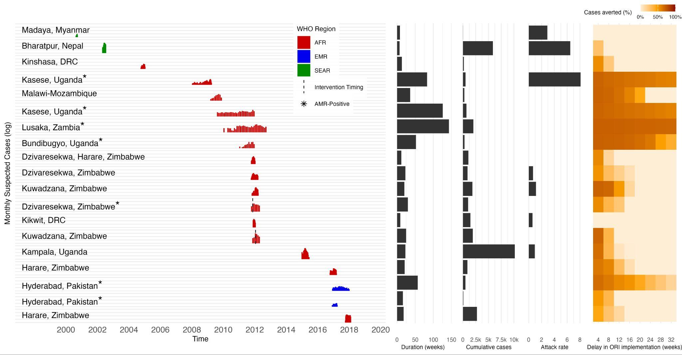
Figure 3. Monthly time series, intervention timing, and AMR-status, and duration, cumulative cases, attack rates, and percent case reduction across delays in ORI (weeks) for 19 outbreaks included in the impact modeling.

Out of the 19 outbreaks, 13 (68%) had at least one AMR-positive case, 1 (5%) outbreaks were negative for AMR, and 5 (26%) outbreaks did not test for AMR. A total of 977 isolates were tested for AMR, in which 889 tested positive. Of those that tested positive, 791 were MDR, 657 were FQ-NS, and 587 were XDR.
In a subset of outbreaks reporting weekly incidence (n = 13), at 80% vaccine coverage, initiating ORI with a 1-week delay led to a median percent case reduction of 66.9% (95% CI: 55.0% – 71.5%), translating to a median of 619 cases averted (95% CI: 32 – 6,129). The median cases averted per 1,000 doses at this delay was 2.5 (95% CI: 0.10 – 42.2) and the median cost per DALY averted was $82,756 (95% CI: 0 - 618,927) (Figure 4). Between week 1 and week 4, the percent case reduction declined by a median of 13.6% (95% CI: 0.9 - 55.9) (or about 4.5% a week), resulting in a 53.9% median case reduction (95% CI: 0% – 70.5%) by week 4. Between week 4 to week 8, the percent case reduction declined by a median of 14.6% (95% CI: 0 - 38.1) (or about 3.7% a week). The percent case reduction reached half of the impact at 1-week delay by week 7 (35.9%, 95% CI: 0% – 68.7%) and week 8 (30.0%, 95% CI: 0% – 68.5%). Similarly, at an 8-week delay in ORI, total cases averted fell to 275 (95% CI: 0 – 2,787), cases averted per 1,000 doses dropped to 0.63 (95% CI: 0.06 – 8.8), and the cost per DALY averted rose to $82,756 (95% CI: 0 – 618,927).
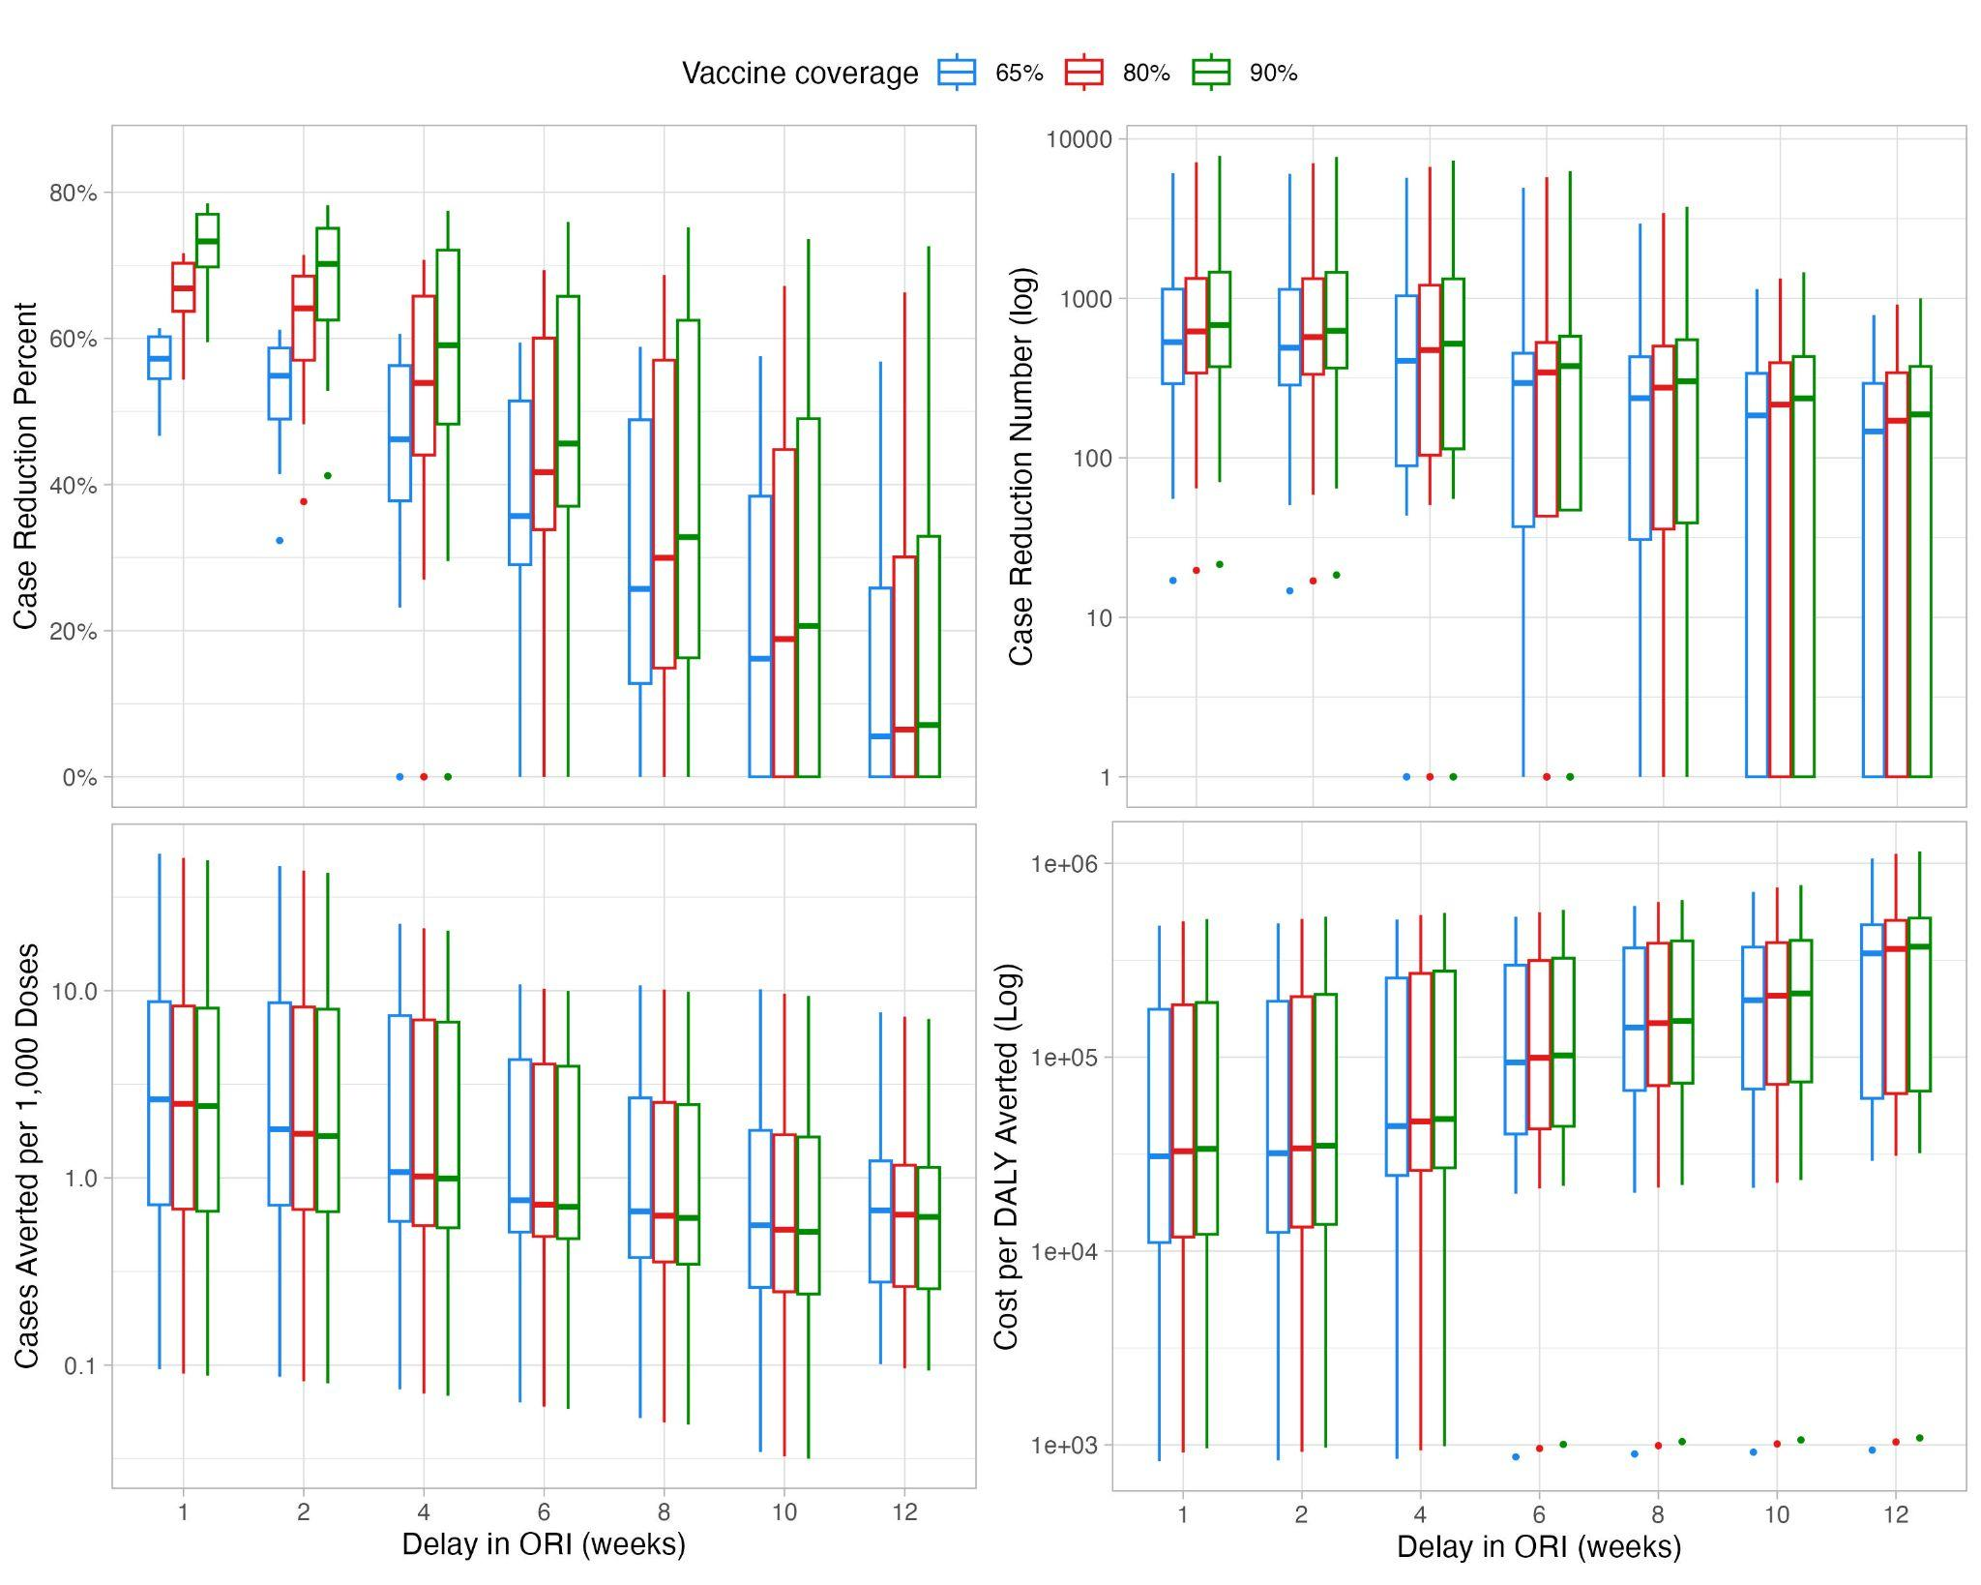
Figure 4. Impact of ORI in weekly reported outbreaks on percent case reduction, case reduction number, cases averted per 1,000 doses, and cost per DALY averted by delay in ORI in weeks and at 65%, 80%, and 90% coverage.

As vaccine coverage increased, cases averted as well as the cost per DALY averted also increased, while the cases averted per 1,000 doses decreased. For instance, at 65% coverage, the percent case reduction was 57.2% (95% CI: 47.2% – 61.2%), with 531 cases averted (95% CI: 28 – 5,250), a cost per DALY averted of $25,916 (95% CI: 994 – 249,055), and 2.6 cases averted per 1,000 doses (95% CI: 0.10 – 44.5). At 90% coverage, percent case reduction rose to 60.3%, with 678 cases averted (95% CI: 35 – 6,714), a higher cost per DALY averted of $28,345 (95% CI: 1,144 – 269,865), and 2.4 cases averted per 1,000 doses (95% CI: 0.10 – 41.1).

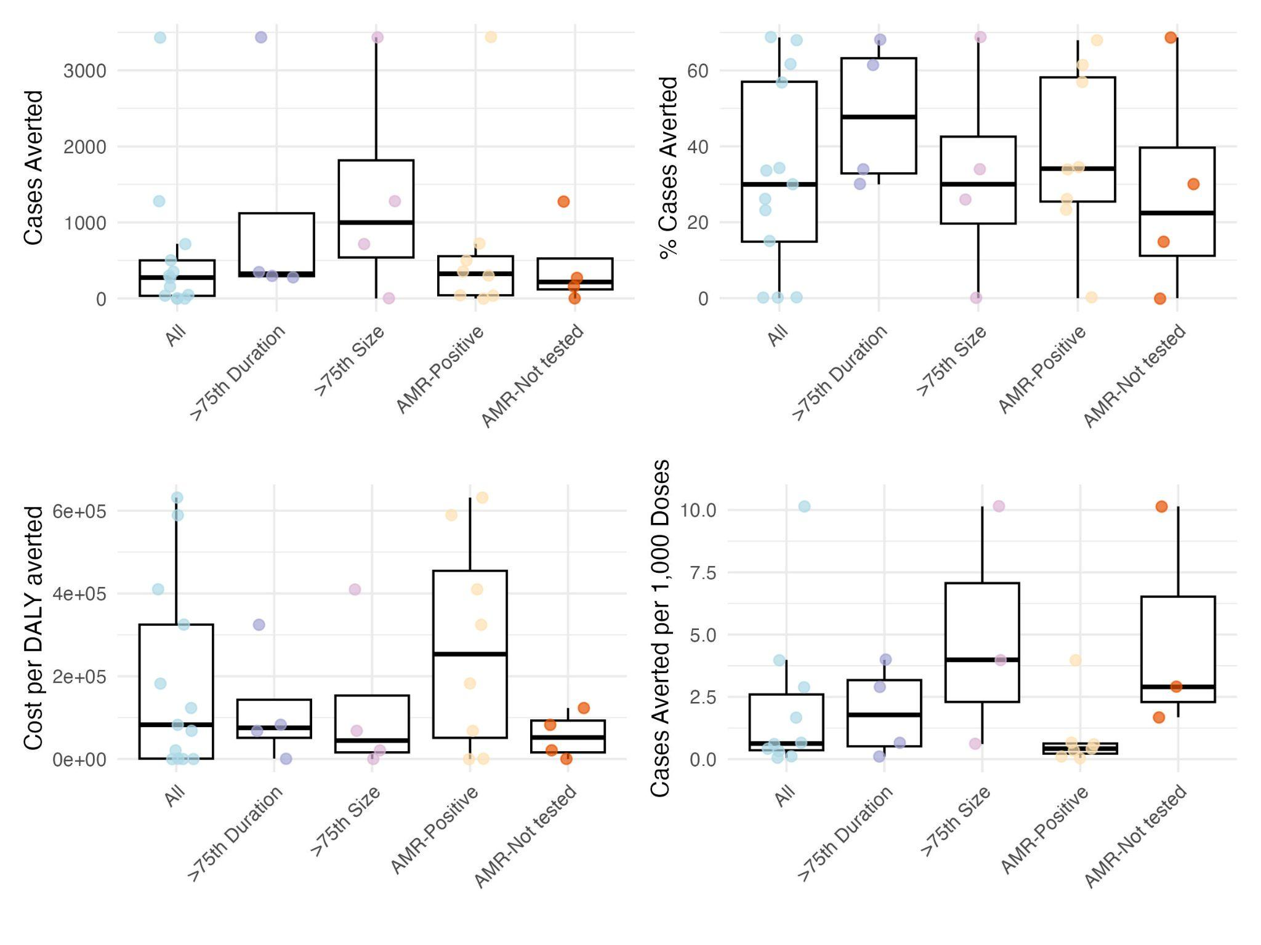
Figure 5. Impact of ORI in all outbreaks reporting weekly incidence and outbreaks stratified by duration, size, and AMR status at 8-week delay and 80% coverage. Median (IQR). Outbreaks that were AMR-Negative (n = 2) had no impact and were excluded from the figure.

Outbreaks stratified by duration, size, and AMR status showed substantial variation in the impact of ORI. Outbreaks lasting longer than the 75th percentile tended to have smaller cumulative cases, with a median of 715 cases. Meanwhile, outbreaks with cumulative cases greater than the 75th percentile tended to be of shorter duration, with a median of 19 weeks long. At 80% vaccine coverage and an 8-week delay, outbreaks lasting longer than the 75th percentile (23 weeks) had a higher median number of cases averted (324, 95% CI: 301–348) and greater percent case reduction (64.8%, 95% CI: 61.8%–67.8%) compared to all outbreaks (30.0%, 95% CI: 0% – 68.5%). However, these outbreaks also had higher costs per DALY averted ($162,861, 95% CI: 9,085–316,638) and lower cases averted per 1,000 doses (0.38, 95% CI: 0.12 – 0.64), assuming uniform distribution of vaccines across the administrative unit. In contrast, outbreaks larger than the 75th percentile showed higher median cases averted (719, 95% CI: 36–3,298), more cases averted per 1,000 doses (2.3, 95% CI: 0.79–3.9), and lower cost per DALY averted ($67,866, 95% CI: 3,393–392,744), but had a lower percent case reduction (26.2%, 95% CI: 1.3–33.4).

AMR-positive outbreaks tended to be both longer (mean: 48 weeks) and larger (mean: 1,945 cumulative cases) than outbreaks that did not test for AMR (mean duration: 16 weeks; mean size: 1,327 cases). These AMR-positive outbreaks had a higher median percent case reduction (34%, 95% CI: 4.1–66.8) and cases averted (324, 95% CI: 6.1–2,959), but also a higher cost per DALY averted ($253,392, 95% CI: 173–624,232) and fewer cases averted per 1,000 doses (0.42, 95% CI: 0.06–3.5), compared to all outbreaks. Similar trends were observed when comparing AMR-positive outbreaks to those without AMR testing, with the exception of cases averted per 1,000 doses, which were notably higher in outbreaks without AMR testing (2.9, 95% CI: 1.7–9.8). The two outbreaks that tested negative for AMR showed no impact at 8-week delays in ORI.

Finally, our sensitivity analyses indicated that outbreaks with monthly incidence data showed patterns very similar to those with weekly incidence, with respect to the influence of vaccine timing and coverage on ORI impact (Supplementary Figure 1). Furthermore, varying the IVE from 0% to 50% had minimal effect on the resulting ORI impact measures (Supplementary Figure 2).

Discussion
This study highlights the considerable potential of outbreak response immunizations (ORIs) to mitigate the burden of typhoid fever outbreaks, based on the modeling of 19 outbreaks reported between 2000 and 2020. While earlier intervention consistently produced the greatest impact, our findings also demonstrate that even delayed responses, such as those implemented 8 weeks after outbreak onset, can meaningfully reduce case burden, particularly in outbreaks characterized by longer durations or higher cumulative incidence. These results underscore the value of ORIs even in scenarios where logistical or operational constraints delay vaccine deployment.
To date, Zimbabwe remains the only country to have received outbreak response support for typhoid from Gavi, the Vaccine Alliance¹⁹. Our results suggest that ORI campaigns using typhoid conjugate vaccine (TCV) could serve as an important adjunct to routine immunization programs, which have been introduced in several high-burden countries, including Malawi and Pakistan³⁹. Importantly, the effectiveness of ORIs depends on outbreak characteristics. Vaccinating during large outbreaks yielded greater absolute case reductions, whereas vaccinating during prolonged outbreaks resulted in higher relative reductions. This pattern likely reflects the inverse relationship observed in our dataset: larger outbreaks tended to be shorter, and longer outbreaks tended to have fewer total cases. Consequently, in the subset of large outbreaks, vaccination prevented a smaller proportion of cases compared with longer outbreaks, yet the number of cases averted remained substantial in absolute terms. These findings underscore the importance of tailoring outbreak response strategies to specific outbreak dynamics, particularly in resource-limited settings where vaccine allocation must be prioritized efficiently.
As such, our findings support greater policy and operational investment in ORI capacity as part of a broader strategy for typhoid control. For instance, although the potential global impact of TCV ORI remains uncertain, our analysis estimates that given a total of 26,298 observed cases (therefore 1,461 per year across 18 years) and a total observed target population of 10,147,833 (therefore 563,769 individuals per year), we could avert 1,409 (96%) and 355 (24%) cases of typhoid each year with a 1-week and 8-week delay in ORI, respectively, and 80% coverage. Across the outbreaks reporting monthly incidence, targeting the total population of 157,950 people annually with an ORI at 8 weeks and 80% coverage would result in 205 (59%) cases averted per year. This is likely a conservative estimate, as it is based solely on outbreaks documented in the published literature and included in this study, and many outbreaks may go unreported.
Previous research, including both modeling and field studies, has consistently demonstrated the effectiveness and cost-effectiveness of TCVs in reducing typhoid fever incidence. Most of these studies, however, have focused on routine immunization strategies. For example, Birger et al. modeled the impact of introducing routine TCV at 9 months of age, supplemented by a catch-up campaign, and predicted that such strategies could avert 46% to 74% of symptomatic cases over ten years in countries eligible for Gavi support³. Similarly, dynamic transmission models described by Burrows et al. estimated reductions in symptomatic typhoid ranging from 10% to 46% with routine immunization alone, and up to 90% when paired with catch-up campaigns in optimistic scenarios⁴. Economic evaluations have further supported TCV introduction as a cost-effective, and often cost-saving, intervention in moderate- to high-incidence settings^{6,7}. However, this remains one of the few real-world examples of outbreak-focused TCV deployment. To our knowledge, our study is the first to use modeling to specifically evaluate the potential impact of ORI with TCV. By simulating ORIs across a diverse set of historical outbreaks, our findings expand the evidence base to include reactive vaccination scenarios, offering important insights into how TCV could be strategically used beyond routine immunization to mitigate ongoing outbreaks.
Despite its strengths, our study has several limitations. First, we assumed uniform vaccine coverage within administrative units, which may overestimate target populations and underestimate the benefits of more spatially targeted vaccination strategies. The previous Harare outbreak targeted nine suburbs with the greatest impact, rather than all of Harare³¹. Spatially focused TCV delivery, such as targeting known high-incidence areas or outbreak hotspots, may achieve greater impact with fewer doses, which is a nuance our model does not capture. Conversely, our assumption of perfect administrative coverage may overestimate vaccine impact. Reactive and routine TCV campaigns face real-world challenges such as cold chain limitations, expiration or spoilage, which contribute to vaccine wastage. For example, post-campaign evaluations of TCV delivery in outbreak settings have shown that administrative coverage may not reflect true immunization rates for all subgroups⁴⁰. However, in the sole Gavi-approved reactive mass vaccination campaign reported in Zimbabwe, vaccine wastage was reported as less than 0.01%³¹. Although we cannot directly quantify these biases, they may partially offset one another.
Second, our parameterization of IVE was informed by estimates from a single cluster-randomized trial^{33,41}. Although this study offers valuable evidence, its findings are context-specific and may not be fully generalizable to other settings, population structures, or transmission dynamics. Reliance on a single source to characterize indirect effects introduces uncertainty and may misrepresent the true magnitude of herd protection, which could bias our estimates of vaccine impact. Nevertheless, our sensitivity analyses, which varied IVE values across a plausible range (0–50%), demonstrated that assumptions about indirect protection had minimal influence on the estimated percent reduction in cases (Supplementary Figure 2). This suggests that our conclusions are relatively robust to uncertainty in IVE, although further data from diverse settings would strengthen confidence in these estimates.
Third, we assume that vaccine impact is restricted to a single outbreak episode. However, evidence suggests that preventive vaccine interventions may confer preemptive benefits by reducing future outbreak risk in the same or neighboring regions⁸. By not modeling these effects, we may underestimate cumulative impact over time. Lastly, our impact estimates are based on the outbreak dataset used, which is limited to a small subset of outbreaks reported in peer-reviewed journals. This introduces selection bias, as these documented outbreaks may differ systematically from unreported incidents (i.e., often being larger, atypical, or subjected to more rigorous surveillance). As such, our findings may not generalize to more typical or undetected outbreak scenarios, potentially limiting the external validity of our conclusions. However, this is the first study to examine such an extensive typhoid outbreak dataset and thus contributes substantially to the current knowledge gap.

Conclusion
This study provides important insights into the effectiveness of ORIs across a broad range of typhoid outbreak scenarios. Our findings underscore the importance of timely intervention and strategic outbreak prioritization to maximize vaccine impact. Looking ahead, the results highlight that even with delayed deployment, targeted allocation can substantially reduce cases and improve the overall efficiency of outbreak response. Together, these findings support the integration of ORIs into broader typhoid control strategies, alongside routine immunization and water, sanitation, and hygiene improvements, to mitigate disease burden and enhance epidemic preparedness.

Supplementary

Supplementary Table 1. Outbreak-specific target population sizes and sources.

Outbreak | Target population size | Source
Michel 2005 | 570 | Original report
Aye 2004 | 1102 | Original report
Muyembe-Tamfum 2009 | 1648557 | Ferrari et al.⁴²
Neil 2012 | 670000 | Original report
Lutterloh 2012 | 277731 | National Statistical Office of Malawi ⁴³
Hendriksen 2015 | 1747152 | Zambia Statistics Agency⁴⁴
Walters 2014, Kasese | 694987 | Uganda Bureau of Statistics⁴⁵
Walters 2014, Bundibugyo | 224387 | Uganda Bureau of Statistics⁴⁵
Ali 2017 | 400000 | Original report
Polonsky 2014, Dzivaresekwa | 118271 | Original report
Polonsky 2014, Kuwadzana | 157396 | Original report
Muti 2014 | 118271 | Polsonky 2014
Imanishi 2014, Dzivaresekwa | 97000 | Original report
Imanishi 2014, Kuwadzana | 129000 | Original report
Kabwama 2017 | 1400000 | Original report
Qamar 2018 | 3500000 | Original report
Davis 2018 | 1485231 | Zimbabwe National Statistics⁴⁰
Yousafzai 2019 | 878418 | Original report
N'Cho 2019 | 1485231 | Zimbabwe National Statistics⁴⁶

Supplementary Table 2. Impact of ORI in weekly reported outbreaks across 65%, 80%, and 90% coverage. Median (IQR).

Delay in ORI (weeks) | Vaccine coverage | Cases averted | % Cases averted | Cost per DALY averted | Cost per case averted | Cost per death averted | Cases averted per 1,000 doses
1 | 65% | 530.5 (290.8, 1142) | 57.2 (54.5, 60.2) | 30866 (14796, 180103) | 1125 (279, 2995) | 0 (0, 21665) | 2.6 (0.7, 8.7)
4 | 65% | 404.7 (88.2, 1036.5) | 46.2 (37.8, 56.3) | 34250 (5836, 229440) | 435 (190, 2971) | 0 (0, 0) | 1.1 (0.6, 7.4)
8 | 65% | 235.6 (29.8, 429.5) | 25.7 (12.8, 48.9) | 78175 (898, 307520) | 1156 (197, 5505) | 0 (0, 0) | 0.7 (0.4, 2.7)
16 | 65% | 0 (0, 73.1) | 0 (0, 8.1) | 0 (0, 268350) | 0 (0, 2645) | 0 (0, 0) | 0.4 (0.1, 0.9)
1 | 80% | 619.1 (339.4, 1332.7) | 66.9 (63.7, 70.3) | 32748 (15755, 189898) | 1194 (296, 3160) | 0 (0, 24011) | 2.5 (0.7, 8.3)
4 | 80% | 472.6 (103, 1208.5) | 53.9 (44, 65.8) | 36384 (6291, 242381) | 460 (202, 3134) | 0 (0, 0) | 1 (0.6, 7)
8 | 80% | 274.6 (34.8, 501.2) | 30 (14.9, 57) | 82756 (991, 324731) | 1214 (209, 5808) | 0 (0, 0) | 0.6 (0.4, 2.6)
16 | 80% | 0 (0, 85.1) | 0 (0, 9.4) | 0 (0, 283751) | 0 (0, 2797) | 0 (0, 0) | 0.4 (0.1, 0.8)
1 | 90% | 678.4 (371.9, 1459.9) | 73.3 (69.8, 77) | 33724 (16255, 195086) | 1230 (305, 3244) | 0 (0, 25235) | 2.4 (0.7, 8.1)
4 | 90% | 518.1 (112.8, 1324.7) | 59.1 (48.3, 72.1) | 37493 (6527, 248852) | 473 (209, 3217) | 0 (0, 0) | 1 (0.6, 6.8)
8 | 90% | 300.5 (38.1, 549.2) | 32.8 (16.3, 62.5) | 85150 (1040, 333718) | 1244 (216, 5964) | 0 (0, 0) | 0.6 (0.3, 2.5)
16 | 90% | 0 (0, 93.2) | 0 (0, 10.3) | 0 (0, 291806) | 0 (0, 2876) | 0 (0, 0) | 0.3 (0.1, 0.8)

Supplementary Table 3. Impact of ORI in monthly reported outbreaks across 65%, 80%, and 90% coverage. Median (IQR).

Delay in ORI (weeks) | Vaccine coverage | Cases averted | % Cases averted | Cost per DALY averted | Cost per case averted | Cost per death averted | Cases averted per 1,000 doses
4 | 65% | 445.4 (237.2, 984.6) | 60 (59.5, 60.8) | 67268 (13521, 151113) | 1578 (425, 2443) | 0 (0, 0) | 1.3 (1, 6)
8 | 65% | 355.4 (209.4, 539.4) | 58.8 (37.2, 60.3) | 71410 (19192, 153364) | 1584 (564, 2489) | 0 (0, 0) | 1.3 (1, 4)
16 | 65% | 157.8 (35.8, 333.1) | 52.6 (12.4, 58) | 65339 (1617, 160727) | 1629 (236, 2880) | 0 (0, 0) | 1 (0.8, 1.2)
32 | 65% | 50.4 (0, 286.1) | 17.2 (0, 46.1) | 3338 (0, 146147) | 487 (0, 2934) | 0 (0, 0) | 0.8 (0.7, 1)
4 | 80% | 521.3 (276.9, 1149.8) | 70 (69.4, 71) | 71138 (14381, 159528) | 1679 (456, 2578) | 0 (0, 0) | 1.2 (1, 5.7)
8 | 80% | 415.6 (244.9, 631.9) | 68.6 (43.5, 70.3) | 75419 (20546, 161930) | 1684 (602, 2626) | 0 (0, 0) | 1.2 (1, 3.8)
16 | 80% | 184.3 (41.9, 388.6) | 61.4 (14.5, 67.7) | 69121 (1748, 169777) | 1732 (255, 3037) | 0 (0, 0) | 1 (0.8, 1.2)
32 | 80% | 58.9 (0, 333.9) | 20.1 (0, 53.9) | 3604 (0, 154342) | 526 (0, 3103) | 0 (0, 0) | 0.7 (0.7, 1)
4 | 90% | 571.8 (303.3, 1259.9) | 76.7 (76, 77.7) | 73156 (14827, 163919) | 1731 (472, 2648) | 0 (0, 0) | 1.2 (1, 5.6)
8 | 90% | 455.8 (268.5, 693.6) | 75.1 (47.8, 77.1) | 77510 (21259, 166399) | 1736 (622, 2697) | 0 (0, 0) | 1.2 (0.9, 3.7)
16 | 90% | 201.8 (45.9, 425.6) | 67.3 (15.9, 74.1) | 71107 (1815, 174482) | 1787 (265, 3120) | 0 (0, 0) | 0.9 (0.8, 1.1)
32 | 90% | 64.6 (0, 365.8) | 22.1 (0, 59) | 3743 (0, 158574) | 547 (0, 3191) | 0 (0, 0) | 0.7 (0.7, 1)
Supplementary Figure 1. Impact of ORI in monthly reported outbreaks on percent case reduction, case reduction number, cases averted per 1,000 doses, and cost per DALY averted by delay in ORI in weeks and at 65%, 80%, and 90% coverage.

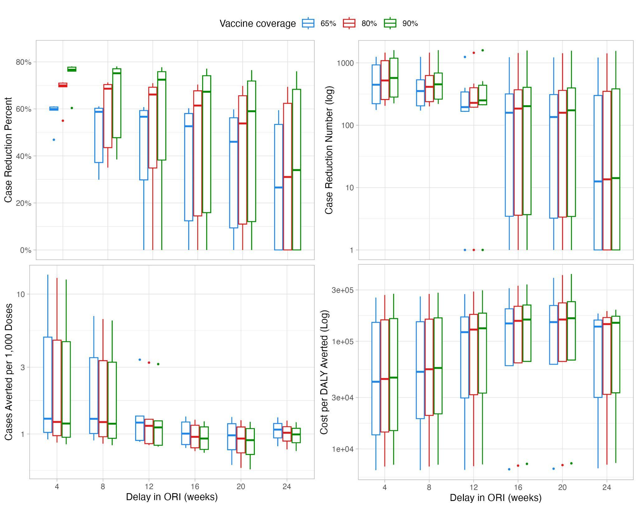

Trends were similar in the subset of outbreaks that reported monthly incidence (n = 6) (Supplementary Figure 1). At an 8-week (or 2-month) delay in ORI and 80% vaccine coverage, median percent case reduction was 69.0% (95%CI: 35.0 - 71.2), corresponding to a median cases averted of 474 (95%CI: 199 - 1,453) cases. Additionally, median cost per DALY averted were $23,770 (95%CI: 6,863 - 275,223) and median cases averted per 1,000 doses were 1.3 (95%CI: 0.9 - 6.6). Impact was affected by vaccine coverage and timing. For example, at an 8-week delay, a 65% vaccine coverage resulted in lower median percent case reduction (59.1%, 95%CI: 29.9 - 61.1) and lower median cases averted (406, 95%CI: 171 - 1,246), and a 90% vaccine coverage resulted in higher median percent case reduction (75.6%, 95%CI: 38.5 - 78.1) and higher median cases averted (519, 95%CI: 218 - 1,593). Furthermore, increasing delay in ORI timing led to generally smaller impact. For example, a 12-week delay resulted in smaller percent case reduction (68.4%, 95%CI: 24.6 - 70.9), cases averted (357, 95%CI: 189 - 1,447), cases averted per 1,000 doses (1.2, 95%CI: 0.8, 3.2), and higher costs per DALY averted ($80,160, 95%CI: 6,909 - 289,662).

Supplementary Figure 2. Impact of varying indirect vaccine effectiveness in ORI with 8-week delay and 80% vaccine coverage on percent case reduction (median, 95%CI) in outbreaks reporting weekly and monthly incidence.

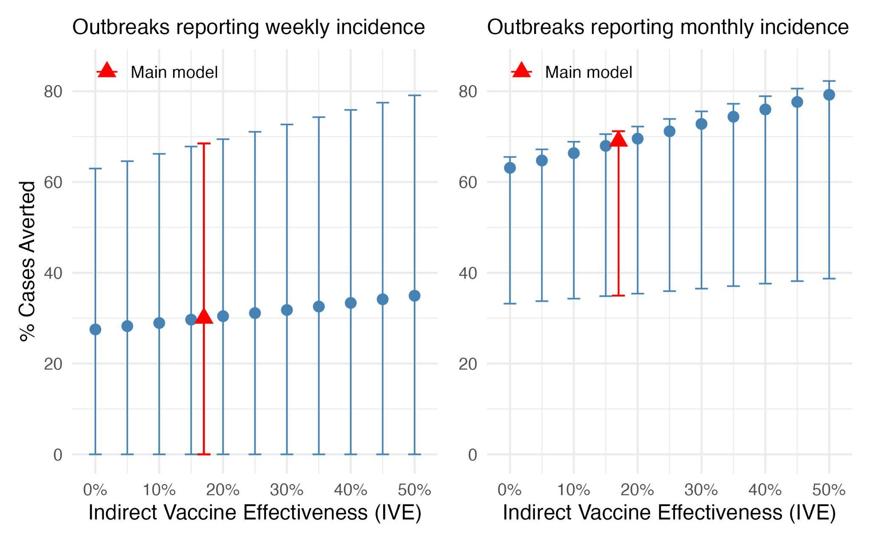

Supplementary Figure 2 shows the effect of varying indirect vaccine effectiveness (IVE) on overall median percent case reduction across the subset of weekly and monthly outbreaks. With IVE ranging from 0% to 50% in ORI with 8-week delay and 80% vaccine coverage, the resulting percent case reduction ranged from 27.5% (95%CI: 0 - 63.0) to 34.9% (95%CI: 0 - 79.1) in outbreaks reporting weekly incidence and ranged from 63.1% (95%CI: 33.2 - 65.5) to 79.2% (95%CI: 38.7 - 82.3) in outbreaks reporting monthly incidence. Estimates from the main model are highlighted in red.

References

1. Antillón M, Bilcke J, Paltiel AD, Pitzer VE. Cost-effectiveness analysis of typhoid conjugate vaccines in five endemic low- and middle-income settings. Vaccine. 2017 Jun;35(27):3506–14.
2. Bilcke J, Antillón M, Pieters Z, Kuylen E, Abboud L, Neuzil KM, et al. Cost-effectiveness of routine and campaign use of typhoid Vi-conjugate vaccine in Gavi-eligible countries: a modelling study. The Lancet Infectious Diseases. 2019 Jul;19(7):728–39.
3. Birger R, Antillón M, Bilcke J, Dolecek C, Dougan G, Pollard AJ, et al. Estimating the effect of vaccination on antimicrobial-resistant typhoid fever in 73 countries supported by Gavi: a mathematical modelling study. The Lancet Infectious Diseases. 2022 May;22(5):679–91.
4. Burrows H, Antillón M, Gauld JS, Kim JH, Mogasale V, Ryckman T, et al. Comparison of model predictions of typhoid conjugate vaccine public health impact and cost-effectiveness. Vaccine. 2023 Jan;41(4):965–75.
5. Chauhan AS, Kapoor I, Rana SK, Kumar D, Gupta M, John J, et al. Cost effectiveness of typhoid vaccination in India. Vaccine. 2021 Jul;39(30):4089–98.
6. Kaufhold S, Yaesoubi R, Pitzer VE. Predicting the Impact of Typhoid Conjugate Vaccines on Antimicrobial Resistance. Clinical Infectious Diseases. 2019 Mar 7;68(Supplement_2):S96–104.
7. Lo NC, Gupta R, Stanaway JD, Garrett DO, Bogoch II, Luby SP, et al. Comparison of Strategies and Incidence Thresholds for Vi Conjugate Vaccines Against Typhoid Fever: A Cost-effectiveness Modeling Study. The Journal of Infectious Diseases. 2018 Nov 10;218(suppl_4):S232–42.
8. Phillips MT, Antillon M, Bilcke J, Bar-Zeev N, Limani F, Debellut F, et al. Cost-effectiveness analysis of typhoid conjugate vaccines in an outbreak setting: a modeling study. BMC Infect Dis. 2023 Mar 8;23(1):143.
9. Pitzer VE, Bowles CC, Baker S, Kang G, Balaji V, Farrar JJ, et al. Predicting the impact of vaccination on the transmission dynamics of typhoid in South Asia: a mathematical modeling study. PLoS Negl Trop Dis. 2014;8(1):e2642.
10. Ryckman T, Karthikeyan AS, Kumar D, Cao Y, Kang G, Goldhaber-Fiebert JD, et al. Comparison of Strategies for Typhoid Conjugate Vaccine Introduction in India: A Cost-Effectiveness Modeling Study. The Journal of Infectious Diseases. 2021 Nov 23;224(Supplement_5):S612–24.
11. Soukavong M, Luangasanatip N, Chanthavilay P, Teerawattananon Y, Dabak SV, Pan-ngum W, et al. Cost-effectiveness analysis of typhoid vaccination in Lao PDR. BMC Public Health. 2023 Nov 17;23(1):2270.
12. Weyant C, Hooda Y, Munira SJ, Lo NC, Ryckman T, Tanmoy AM, et al. Cost-effectiveness and public health impact of typhoid conjugate vaccine introduction strategies in Bangladesh. Vaccine. 2024 Apr;42(11):2867–76.
13. Crump JA, Sjölund-Karlsson M, Gordon MA, Parry CM. Epidemiology, Clinical Presentation, Laboratory Diagnosis, Antimicrobial Resistance, and Antimicrobial Management of Invasive Salmonella Infections. Clin Microbiol Rev. 2015 Oct;28(4):901–37.
14. Global Burden of Disease Collaborative Network. Global Burden of Disease Study 2021 (GBD 2021) GBD Results [Internet]. Seattle, United States: Institute for Health Metrics and Evaluation; 2024 [cited 2025 Jan 7]. Available from: https://vizhub.healthdata.org/gbd-results/
15. Walker J, Chaguza C, Grubaugh ND, Carey M, Baker S, Khan K, et al. Assessing the global risk of typhoid outbreaks caused by extensively drug resistant Salmonella Typhi. Nat Commun. 2023 Oct 16;14(1):6502.
16. Koh DH, Duong M, Kipshidze N, Pitzer VE, Kim JH. Time series data on typhoid fever incidence during outbreaks from 2000 to 2022. Sci Data. 2025 Jan 16;12(1):94.
17. Tamrakar D, Poudel P, Thapa P, Singh S, Khadgi A, Thapa S, et al. Safety and immunogenicity of conjugate vaccine for typhoid (Vi-DT): Finding from an observer-blind, active-controlled, randomized, non-inferiority, phase III clinical trial among healthy volunteers. Hum Vaccin Immunother. 2024 Dec 31;20(1):2301631.
18. Typhoid Vaccine Acceleration Consortium. Typhoid Vaccines [Internet]. 2024 [cited 2025 Jan 10]. Available from: https://www.coalitionagainsttyphoid.org/the-issues/typhoid-vaccines/
19. UNICEF Supply Division. Typhoid Conjugate Vaccine: Supply and Demand Update [Internet]. 2022 Dec [cited 2025 Jan 10]. Available from: https://www.unicef.org/supply/media/15236/file/Typhoid-Conjugate-Vaccine-Supply-and-Demand-Update-December-2022.pdf
20. World Health Organization. ZyVac TCV (Typhoid Vi Conjugate Vaccine) - WHO Public Assessment Report (WHOPAR) [Internet]. 2024 [cited 2025 Jan 10]. Available from: https://extranet.who.int/prequal/sites/default/files/vwa_vaccine/fvp-p-442_typhoid_5doses_zydus_whopar-2024.pdf
21. Gavi, the Vaccine Alliance. Eligibility policy [Internet]. Gavi, the Vaccine Alliance; 2025 May [cited 2025 Aug 11]. Available from: https://www.gavi.org/programmes-impact/programmatic-policies/eligibility-policy
22. Halloran ME, Haber M, Longini IM, Struchiner CJ. Direct and Indirect Effects in Vaccine Efficacy and Effectiveness. American Journal of Epidemiology. 1991 Feb 15;133(4):323–31.
23. Jin C, Gibani MM, Moore M, Juel HB, Jones E, Meiring J, et al. Efficacy and immunogenicity of a Vi-tetanus toxoid conjugate vaccine in the prevention of typhoid fever using a controlled human infection model of Salmonella Typhi: a randomised controlled, phase 2b trial. The Lancet. 2017 Dec;390(10111):2472–80.
24. Nampota-Nkomba N, Nyirenda OM, Khonde L, Mapemba V, Mbewe M, Ndaferankhande JM, et al. Safety and immunogenicity of a typhoid conjugate vaccine among children aged 9 months to 12 years in Malawi: a nested substudy of a double-blind, randomised controlled trial. The Lancet Global Health. 2022 Sep;10(9):e1326–35.
25. Sirima SB, Ouedraogo A, Barry N, Siribie M, Tiono A, Nébié I, et al. Safety and immunogenicity of Vi-typhoid conjugate vaccine co-administration with routine 9-month vaccination in Burkina Faso: A randomized controlled phase 2 trial. International Journal of Infectious Diseases. 2021 Jul;108:465–72.
26. Forgacs D, Jang H, Abreu RB, Hanley HB, Gattiker JL, Jefferson AM, et al. SARS-CoV-2 mRNA Vaccines Elicit Different Responses in Immunologically Naïve and Pre-Immune Humans. Front Immunol. 2021;12:728021.
27. ClinicalTrials.gov. Safety and Immunogenicity of a Novel Conjugate Vaccine Against Salmonella Typhi and Salmonella Paratyphi A in Healthy Adults [Internet]. National Library of Medicine. 2025. Available from: https://clinicaltrials.gov/study/NCT05613205?tab=history
28. Renardy M, Joslyn LR, Millar JA, Kirschner DE. To Sobol or not to Sobol? The effects of sampling schemes in systems biology applications. Mathematical Biosciences. 2021 Jul;337:108593.
29. International Monetary Fund. Inflation rate, average consumer prices [Internet]. Available from: https://www.imf.org/external/datamapper/PCPIPCH@WEO/OEMDC/ADVEC/WEOWORLD
30. Hancuh M, Walldorf J, Minta AA, Tevi-Benissan C, Christian KA, Nedelec Y, et al. Typhoid Fever Surveillance, Incidence Estimates, and Progress Toward Typhoid Conjugate Vaccine Introduction — Worldwide, 2018–2022. MMWR Morb Mortal Wkly Rep. 2023 Feb 17;72(7):171–6.
31. Poncin M, Marembo J, Chitando P, Sreenivasan N, Makwara I, Machekanyanga Z, et al. Implementation of an outbreak response vaccination campaign with typhoid conjugate vaccine – Harare, Zimbabwe, 2019. Vaccine: X. 2022 Dec;12:100201.
32. Batool R, Qamar ZH, Salam RA, Yousafzai MT, Ashorn P, Qamar FN. Efficacy of typhoid vaccines against culture-confirmed Salmonella Typhi in typhoid endemic countries: a systematic review and meta-analysis. The Lancet Global Health. 2024 Apr;12(4):e589–98.
33. Qadri F, Khanam F, Liu X, Theiss-Nyland K, Biswas PK, Bhuiyan AI, et al. Protection by vaccination of children against typhoid fever with a Vi-tetanus toxoid conjugate vaccine in urban Bangladesh: a cluster-randomised trial. The Lancet. 2021 Aug;398(10301):675–84.
34. Global Burden of Disease Collaborative Network. Global Burden of Disease Study 2021 (GBD 2021) Disability Weights [Internet]. Seattle, United States: Institute for Health Metrics and Evaluation; 2024 [cited 2025 Jan 7]. Available from: https://ghdx.healthdata.org/record/ihme-data/gbd-2021-disability-weights
35. GBD 2017 Disease and Injury Incidence and Prevalence Collaborators. Global, regional, and national incidence, prevalence, and years lived with disability for 354 diseases and injuries for 195 countries and territories, 1990-2017: a systematic analysis for the Global Burden of Disease Study 2017. Lancet. 2018 Nov 10;392(10159):1789–858.
36. UNICEF. Typhoid conjugate vaccine (TCV) price data [Internet]. 2024. Available from: https://www.unicef.org/supply/documents/typhoid-conjugate-vaccine-tcv-price-data
37. United Nations, Department of Economic and Social Affairs, Population Division. World Population Prospects 2024, Online Edition [Internet]. 2024. Available from: https://population.un.org/wpp/Download/Standard/Mortality/
38. World Bank Group. GDP per capita (current US$) [Internet]. Available from: https://data.worldbank.org/indicator/NY.GDP.PCAP.CD
39. U.S. Centers For Disease Control and Prevention. Global Typhoid Fever Vaccination [Internet]. 2024 [cited 2025 Jul 8]. Available from: https://www.cdc.gov/typhoid-fever/php/global-typhoid-fever/index.html
40. Gharpure R, Longley AT, Takamiya M, Hidle A, Munyanyi M, Chawurura T, et al. Typhoid conjugate vaccine perceptions and coverage among children and adults: Findings from a post-campaign coverage survey - Harare, Zimbabwe, 2019. Vaccine. 2024 Oct 24;42(24):126086.
41. Khanam F, Kim DR, Liu X, Voysey M, Pitzer VE, Zaman K, et al. Assessment of vaccine herd protection in a cluster-randomised trial of Vi conjugate vaccine against typhoid fever: results of further analysis. eClinicalMedicine. 2023 Apr;58:101925.
42. Ferrari G, Ntuku HM, Schmidlin S, Diboulo E, Tshefu AK, Lengeler C. A malaria risk map of Kinshasa, Democratic Republic of Congo. Malar J. 2016 Dec;15(1):27.
43. National Statistical Office of Malawi. Malawi Data Portal [Internet]. 2018 [cited 2025 Aug 15]. Available from: https://malawi.opendataforafrica.org/gesljee/population-2018
44. Zambia Statistics Agency. Zambia Data Portal [Internet]. 2015 [cited 2025 Aug 15]. Available from: https://zambia.opendataforafrica.org/
45. Uganda Bureau of Statistics. Data Dissemination Portal [Internet]. 2014 [cited 2025 Aug 15]. Available from: https://statistics.ubos.org/
46. Zimbabwe National Statistics Agency. Zimbabwe Data Portal [Internet]. 2012 [cited 2025 Aug 15]. Available from: https://zimbabwe.opendataforafrica.org/

